Observations:

* Menu
  + Background
  + Name of game
  + Menu options
    - Game Start
    - Extra Start
    - Practice Start
    - Replay
    - Player Data
    - Music Room
    - Option
    - Quit
  + Control menu with both key arrows & enter and mouse
* Enter name for score streak tracking
* Easy level
  + Moving stage towards player sprite
  + Player sprite changes costumes standing still (skirt moving) and left to right (similar to midlevel boss)
  + Low level enemies swing down in simple, alternating patterns (3)
    - Change costumes as they move and stay still (wings flap)
  + Mid boss enters and shoots
    - 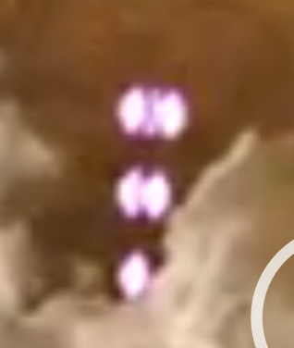 they spread out
    - Moves while shooting
    - Travels out of screen and stops shooting
  + Second mid boss enters and shoots (different direction from previous)
    - “ “ “
  + Low level enemies swing down in simple, alternating patterns (1)
  + Third mid boss enters and shoots
    - Low level enemies continue to swing around mid boss
      * Pattern changes
      * 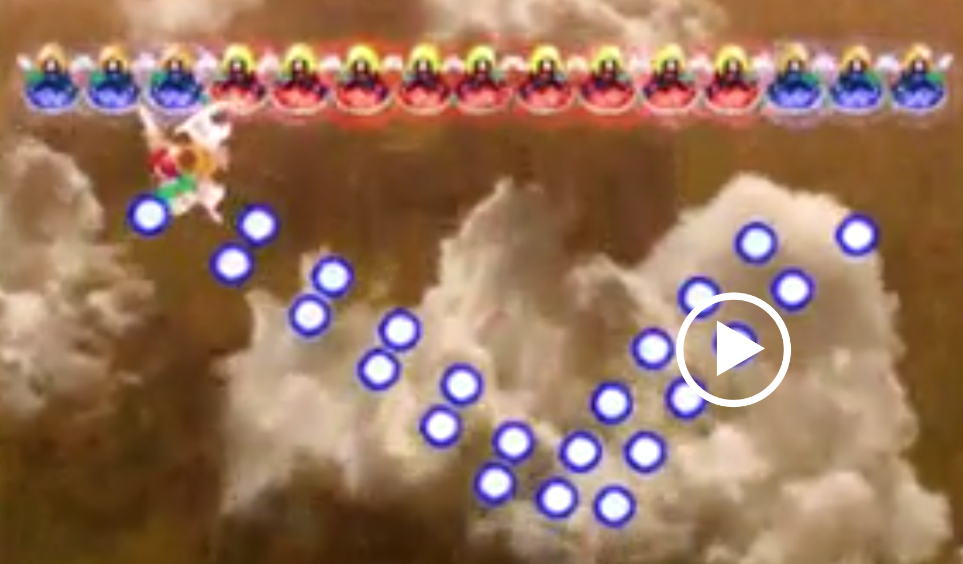
      * They shoot these things
      * Travel out of screen
    - Travels out of screen
  + Fourth mid boss
    - different shooting and moving pattern
      * 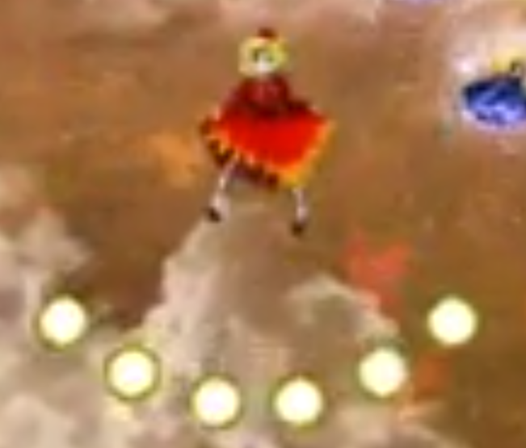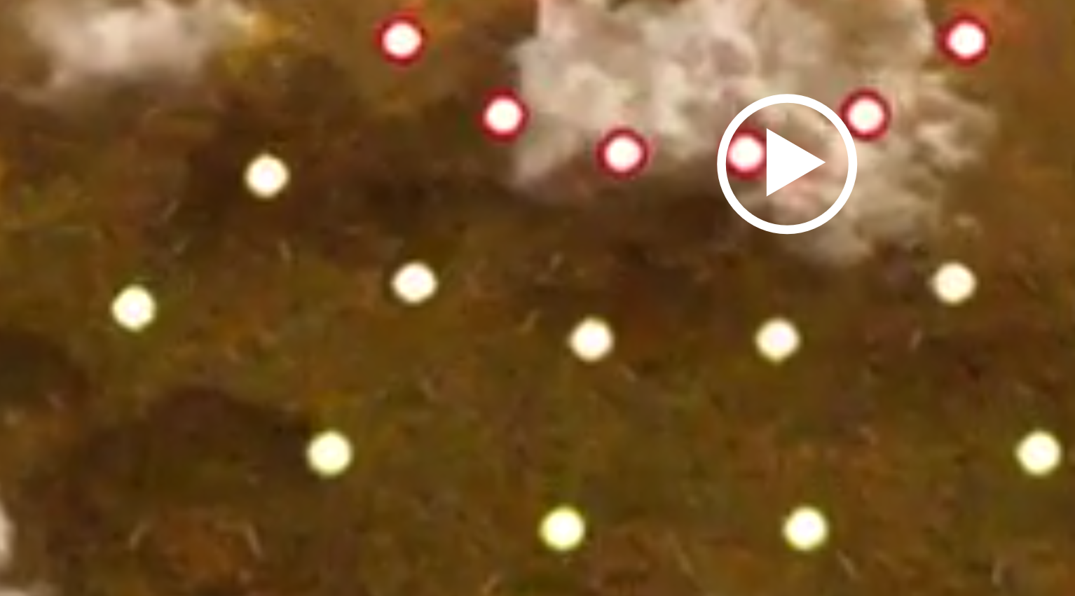
      * Bullets spread
    - She dashes from left to right with small pauses in between
    - Sprite costume changes as she dashes
    - Second shooting pattern
      * 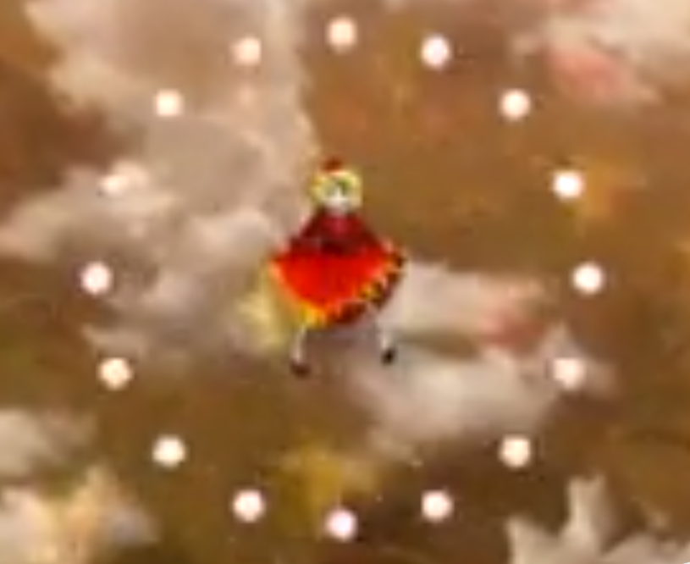
      * Rapid bursts that spread out
    - Alternates between shooting patterns 1 and 2
    - Path and shoot patterns seem to repeat (fixed)
    - 5th and 6th mid boss (first type)
      * Fly over each other and shooting overlaps
      * 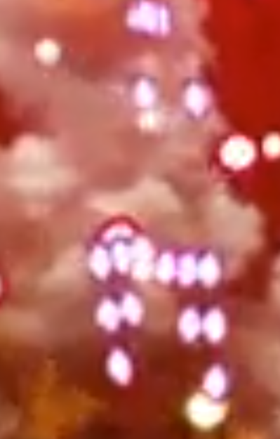
    - Lower level bosses fly towards player
    - 5th and 6th mid bosses dip
    - 4th mid boss dips
  + 7th and 8th mid bosses come in (first type)
    - Lower level enemies swing down once
    - Then: 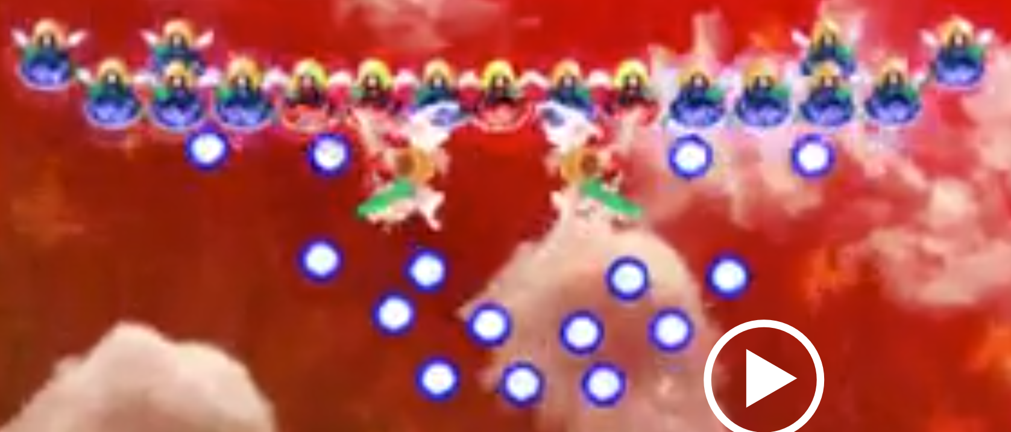
    - All bosses fly out
* While stage is clear, main player has text box, high level boss pops up with text box too, and flies into center
  + 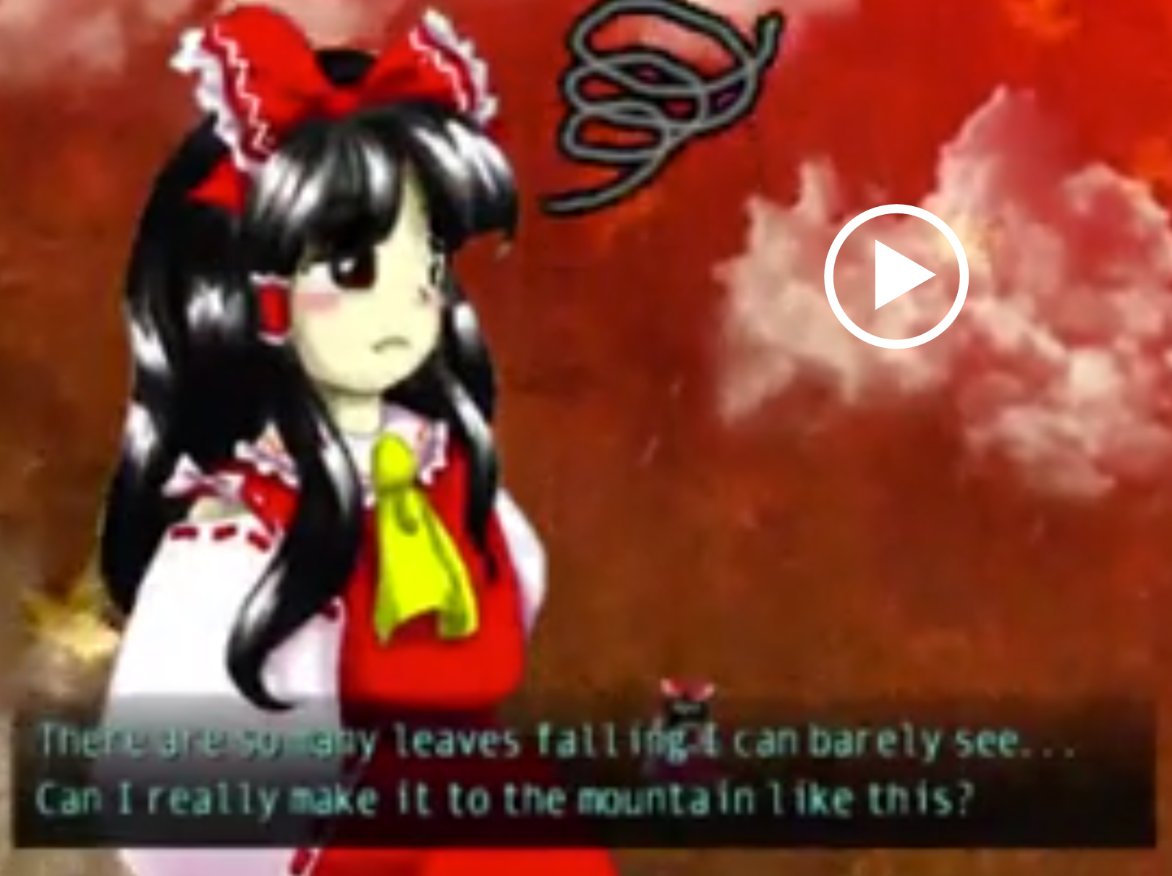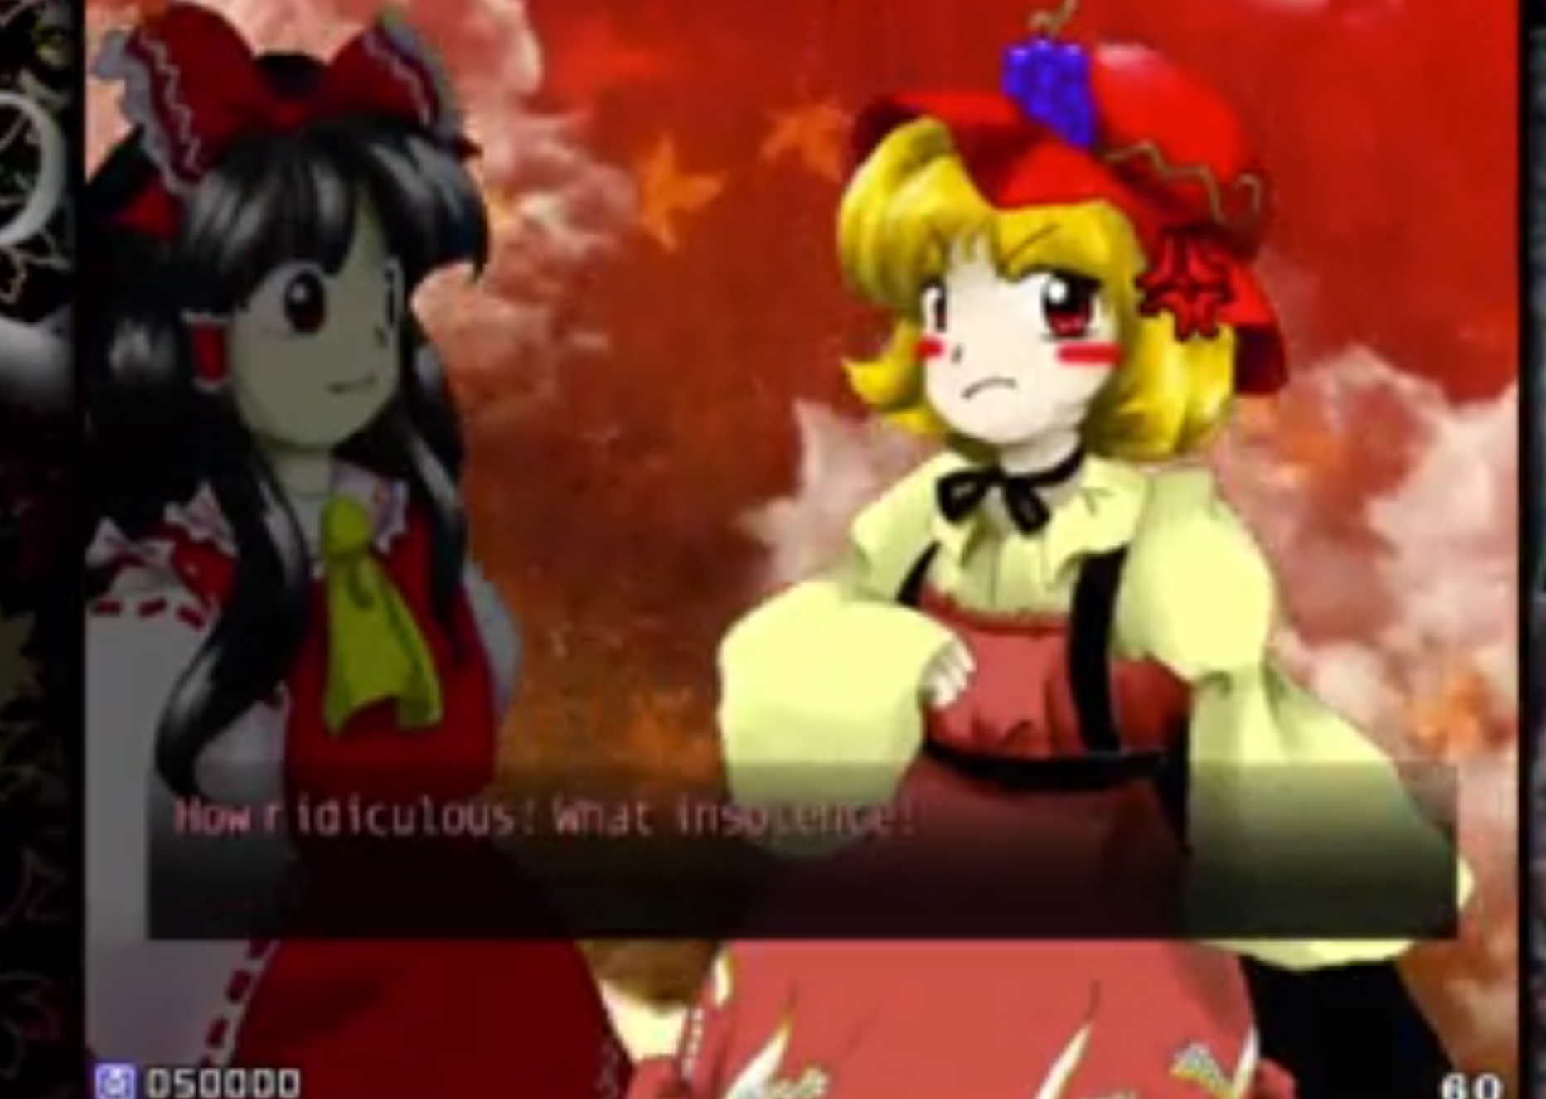
  + Moves similar to mid level boss of second type
  + Spiral bullets
    - 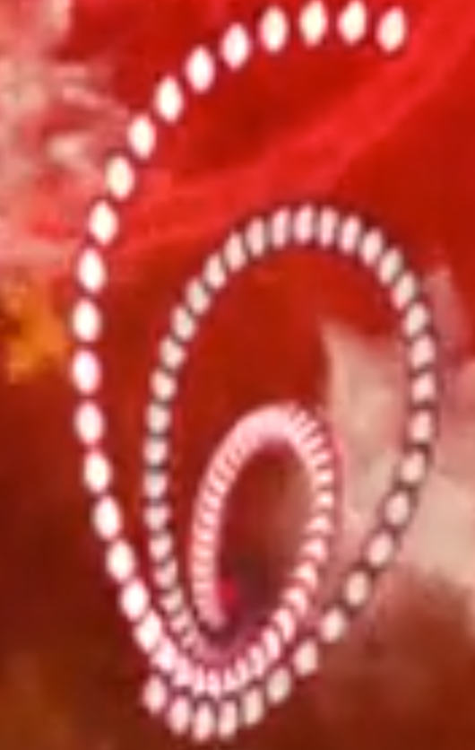
    - ends follow spiral path
    - they get narrower as they approach,
    - they rotate in 3D
      * 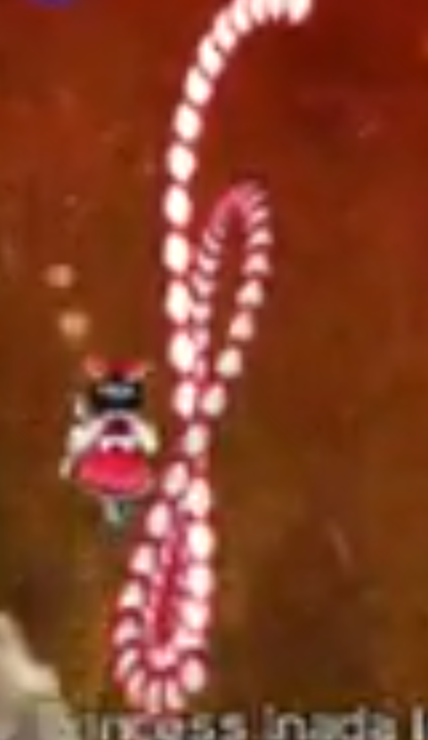
  + 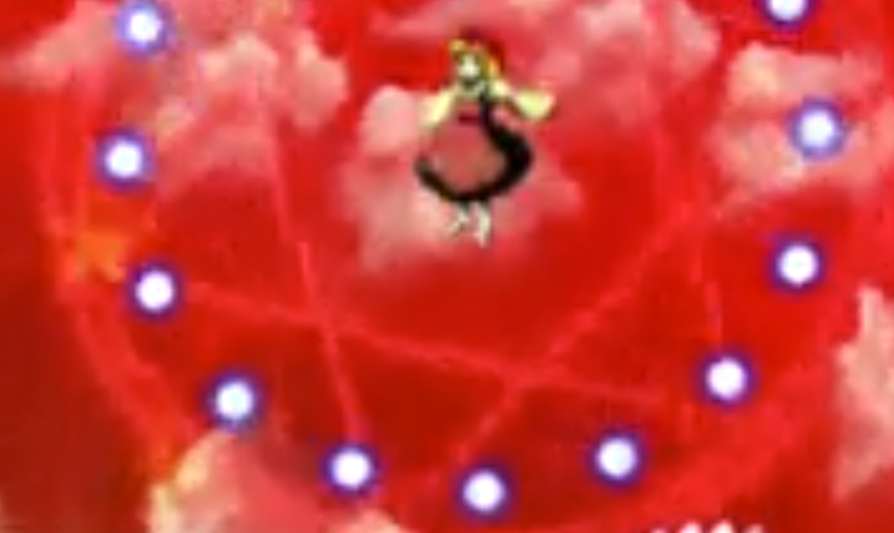
  + Switches between both types of bullets 1 spiral, 2 outbursts
  + Boss battle gets more intense with stage background shift
    - Shooting style changes
    - 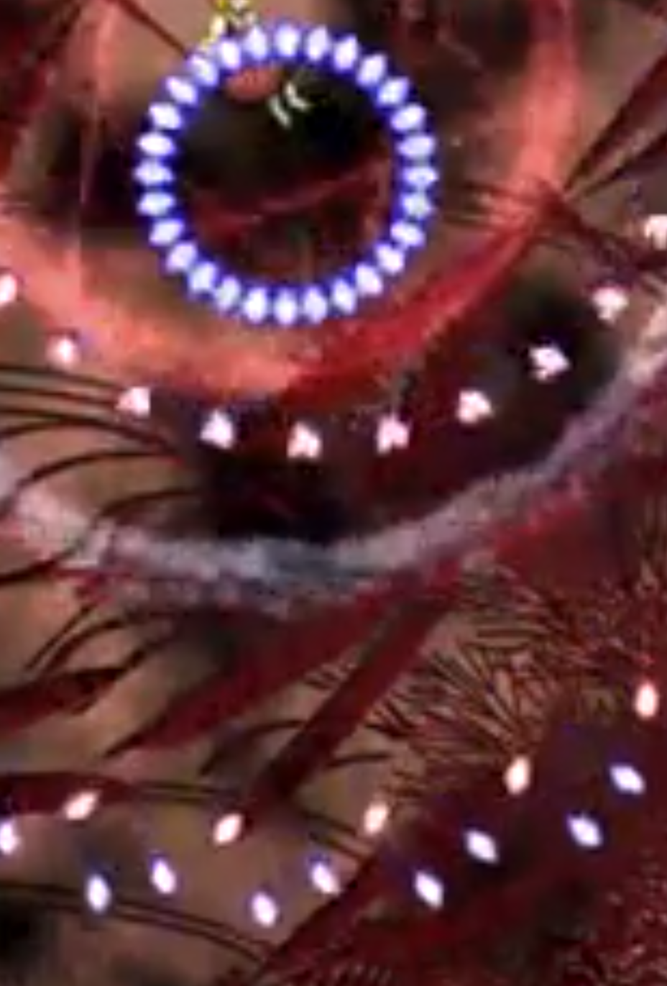
      * Two bullets of different colors overlap and separate in different directions
      * Rapid bursts
      * (3) pulses spread out, stop as bullets rotate (shine?), and start again
      * Blue bullets double with third pulse
    - 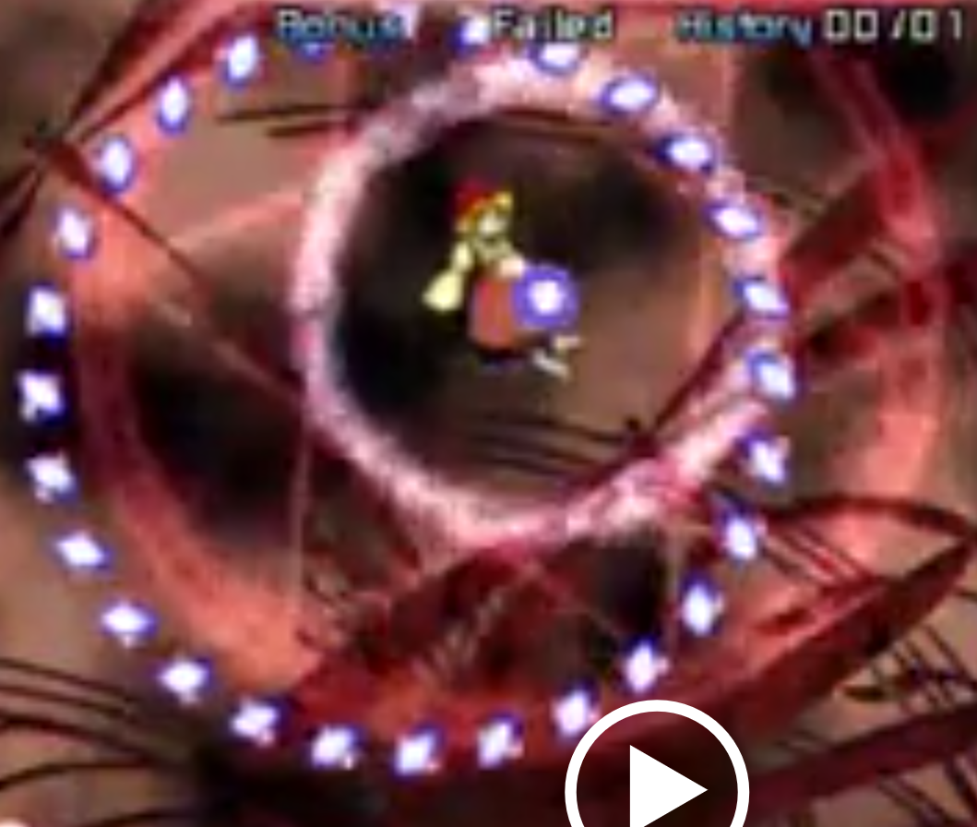
      * There is a rotating red backdrop surrounding and following boss sprite
        + It closes as timer goes down, disappears once time is up
  + Boss battle gets less intense, stage change again, spiral shooting pattern changed (every 45 seconds):
    - Phases are being timed
    - Three spiral paths are aimed in different directions
    - 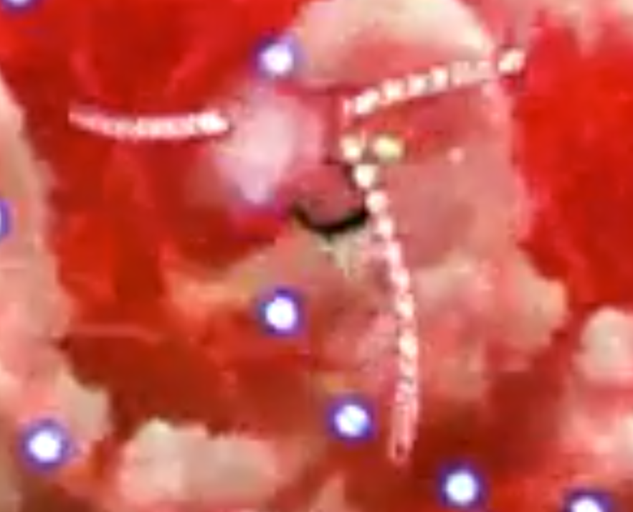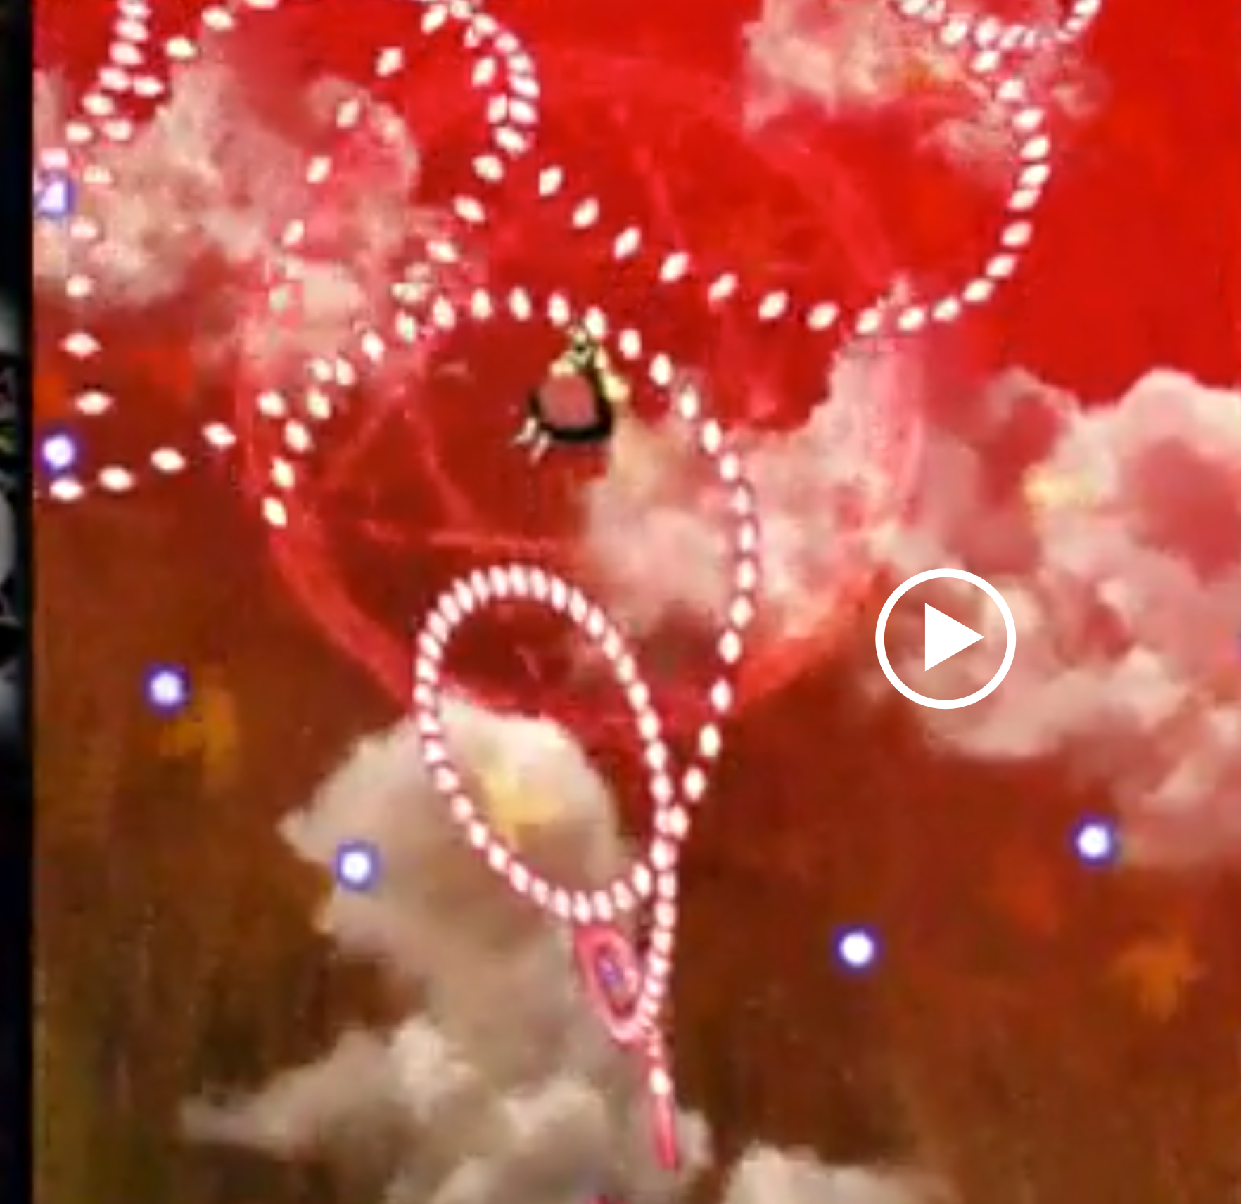
  + Boss battle get intense again, stage change, circles around boss, shooting patterns change
    - 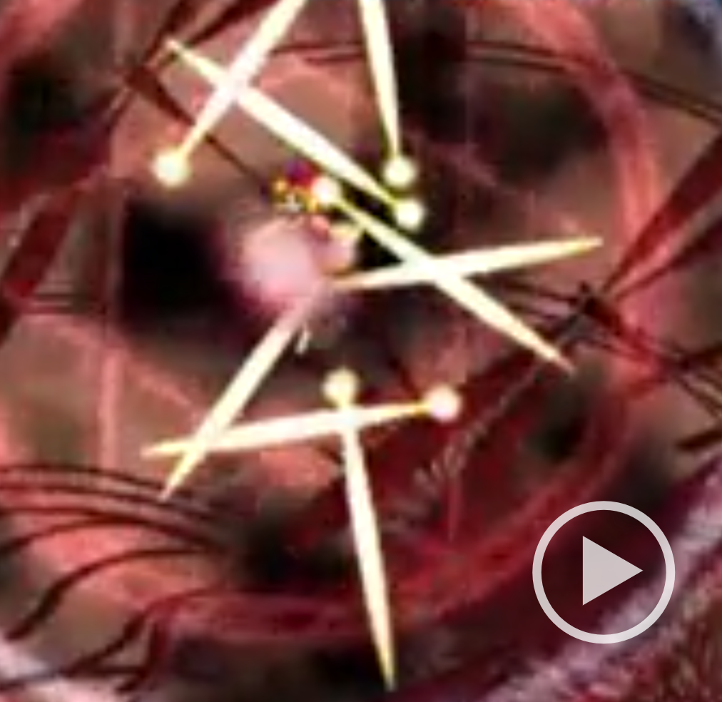 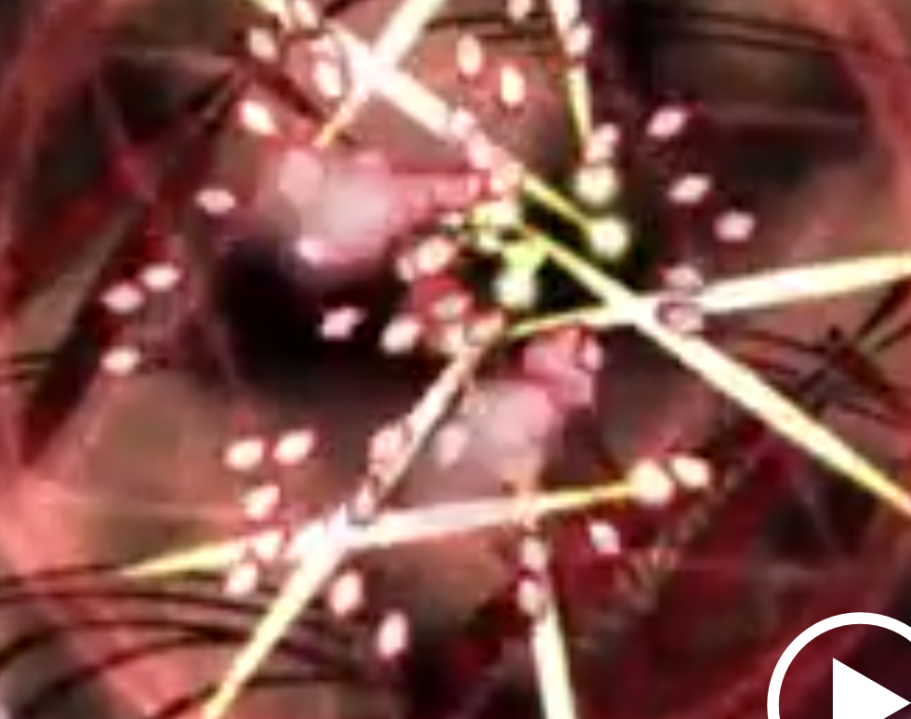
      * 2 Circle drawn around character as bullets are shot in every direction
        + 1 moves clockwise and the other CCW
      * Long needles spawn pointing at random directions
        + Follow similar spread out path every time
        + 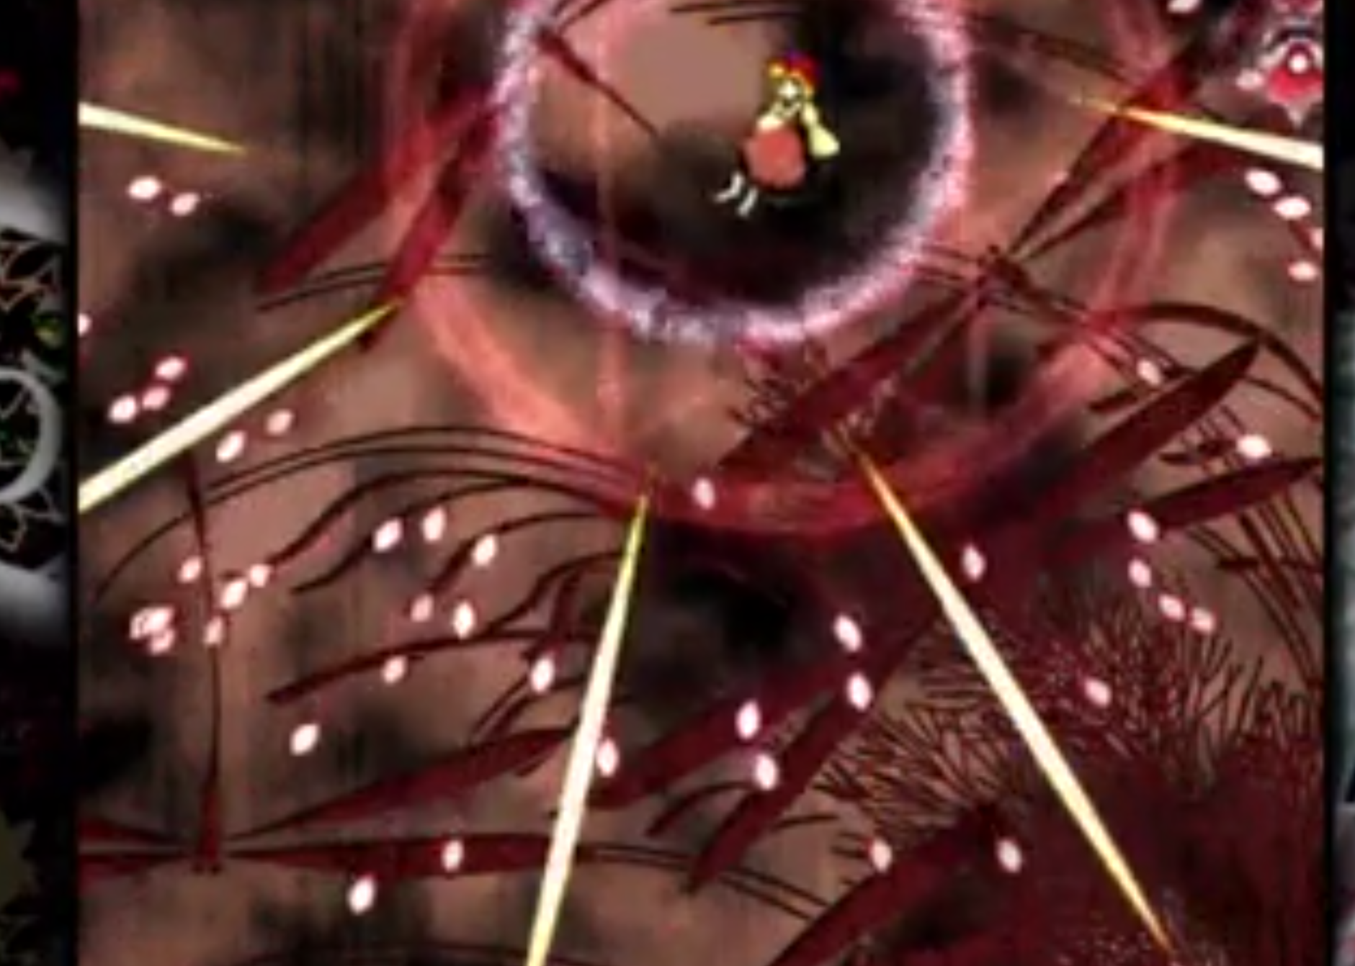 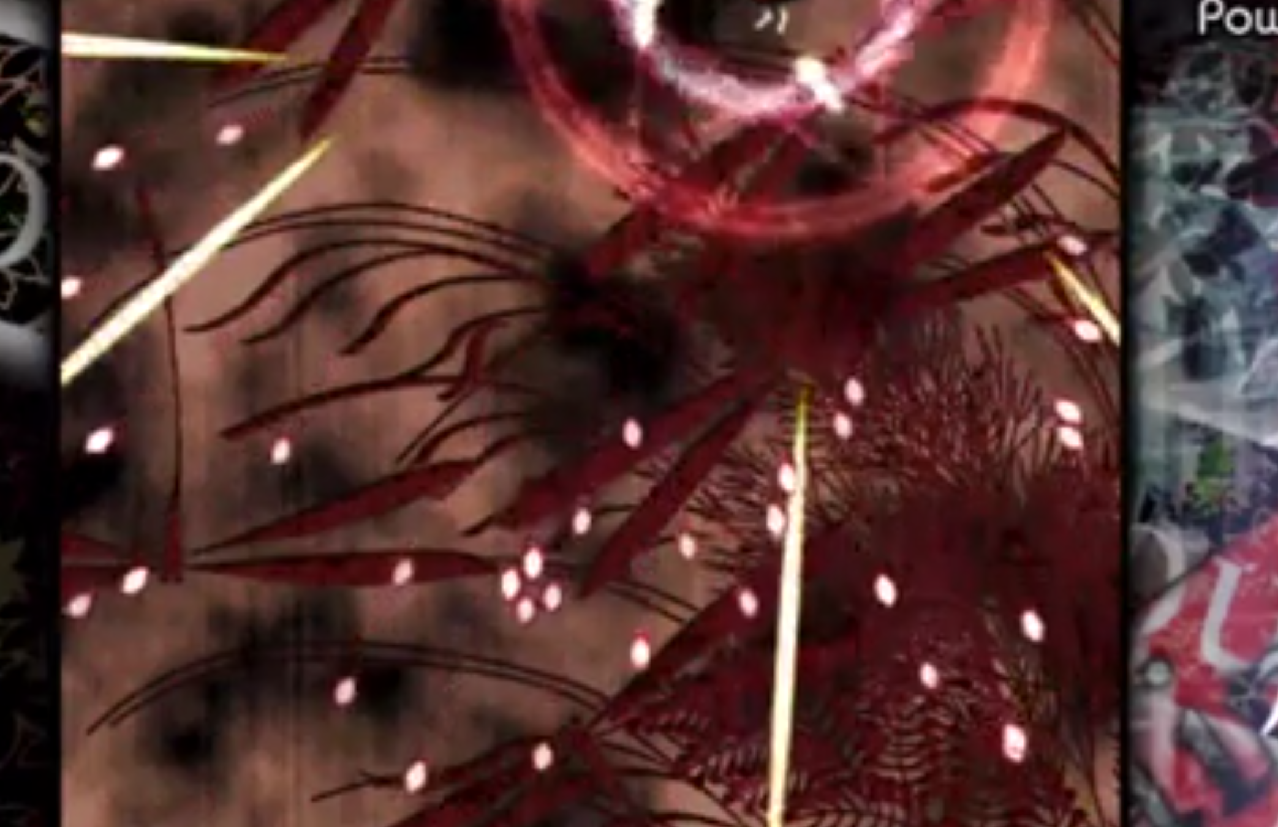 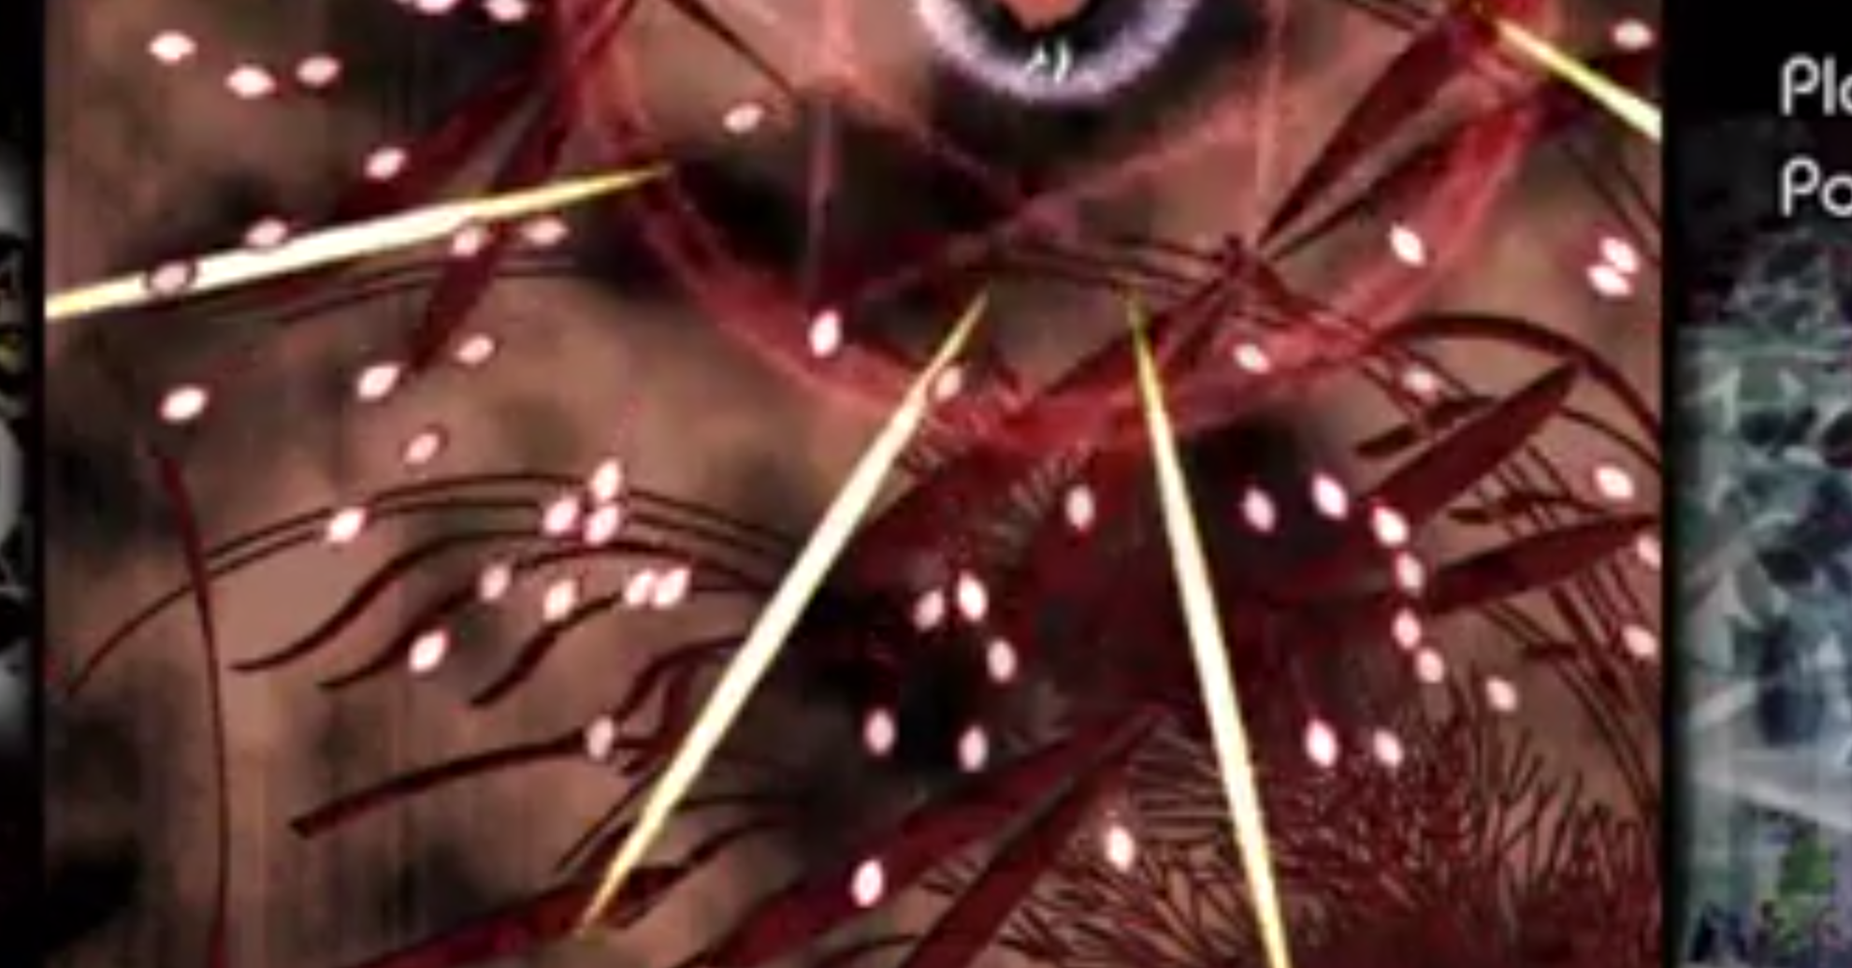
  + Round ends, player has text, game is paused and video ends
* If bullet hits, sprite blows up somehow, blocks come out of it
  + 
    - When she picks up enough: 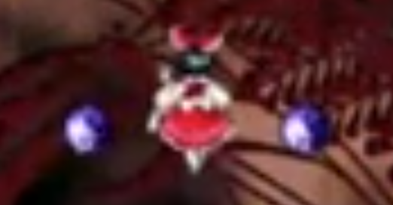
    - Power goes up